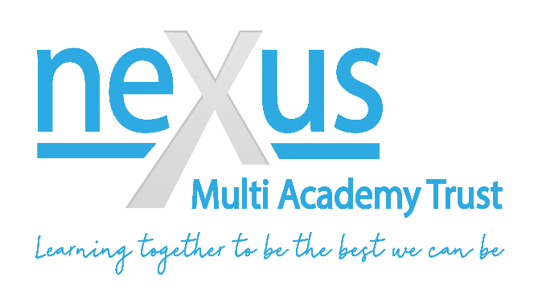

AGENDA
Standards Committee Meeting
Monday 6th December 2021 at 17:00 – 19:00
at Nexus HQ

- APOLOGIES FOR ABSENCE
  - To accept apologies for absence
  - To receive apologies for absence

- ITEMS OF URGENT BUSINESS
  - Chair to determine any items of urgent business to be considered

- DECLARATION OF INTERESTS
  - Individual Directors to declare any personal, business or other governance interests on any item on the agenda

- APPROVAL OF COMMITTEE MINUTES
  - To approve the minutes of the following meeting:
4.1.1 Standards Committee meeting held on 12th July 2021 (attached document)
  - Review of Action Tracker (attached document)
  - Matters arising from the Minutes

- ITEMS TO BE CONSIDERED
  - MAT Assurance Framework – Self Assessment (attached document)
  - Collaborative School Improvement Framework (attached document)
    - CSIF Delivery Plan 2021-22 (attached document)
    - Careers Report (attached document)
  - Academies – Performance Dashboard Report (attached documents)
  - Risk Register (attached document)
  - Draft HR Balanced Scorecard Format (attached document)
  - Bader Academy – Executive Oversight Report (attached document)
  - SCR Audit & Spot Checks – Report (attached document)

- ANY OTHER URGENT BUSINESS
  - To consider any other urgent business agreed by the Chair

- CONFIDENTIALITY & RISK
  - To consider the confidentiality of any items discussed during the meeting
  - To consider any areas of risk discussed during the meeting

- DATES OF NEXT MEETINGS

Monday 6th December 2021 | 17:00 – 19:00 | Nexus HQ
Monday 28th March 2022 | 17:00 – 19:00 | Nexus HQ
Tuesday 28th June 2022 | 16:00 – 19:00 | Leadership Summit  Crags School
Monday 18th July 2022 | 17:00 – 19:00 | Nexus HQ

